Similar Triangle Worksheet
- For each of the following pairs of similar triangles;
- Which angles match?
- Which sides have the same scale factor?
- Which rule can I prove?
- Write the proof (with similarity statement).
- Find the value of the pronumeral

a) b)
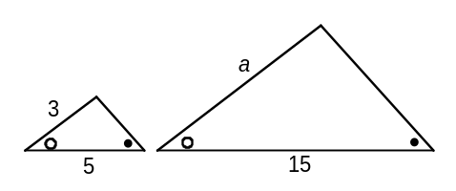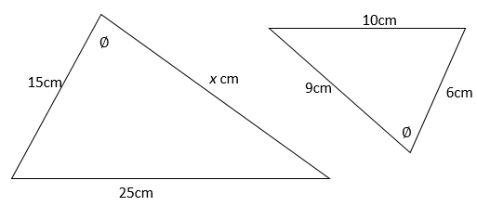

- (i)

- (ii)

- (iii)

- (iv)

- (v)

c) d)
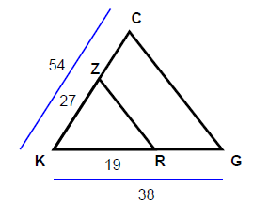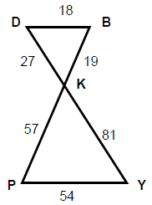

- (i)

- (ii)

- (iii)

- (iv)

- (v)

